Payroll System

User Manual

Table of Contents
Payroll System 1
User Manual 1
Table of Contents 2
Dashboard 3
Workforce Management 4
Overview 4
1. Departments 4
2. Divisions 5
3. Employment Types 6
4. Job Titles 7
Account Management 9
5. Users 9
6. User Roles 11
Employee Leaves 13
7. Payslip Generator 15
System Documents 16
Overview 16

Dashboard
- The Dashboard contains stats about the entire organization from Departments, Users and Leave requests. This dashboard view can be seen by the Administrators, Developers and System Administrators only, normal users have a plain dashboard.
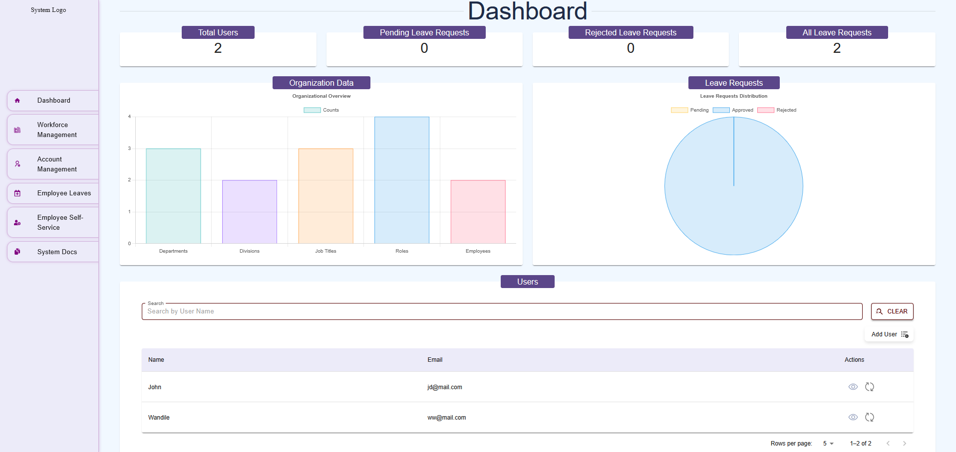

Workforce Management

Overview
The Workforce Management section of the payroll system serves as the central hub for managing organizational data. It organizes and maintains critical information about the company's structure, including Departments, Divisions, Employment Types, and Job Titles. This module ensures that employee data is accurately categorized, enabling seamless payroll processing, reporting, and compliance with organizational policies.

Departments
Departments represent the primary organizational units where employees are assigned based on their roles and functions within the company. Each department is a high-level grouping that aligns with the company's operational structure.
- Purpose: To categorize employees into broad functional areas (e.g., Finance, Human Resources, IT, Sales).
- Examples:
  - Finance
  - Marketing
  - Operations
  - Information Technology
- Key Features:
  - Create, edit, or deactivate departments.
  - Assign a department head or manager for oversight.
  - Link departments to specific cost centers for budgeting and financial reporting.

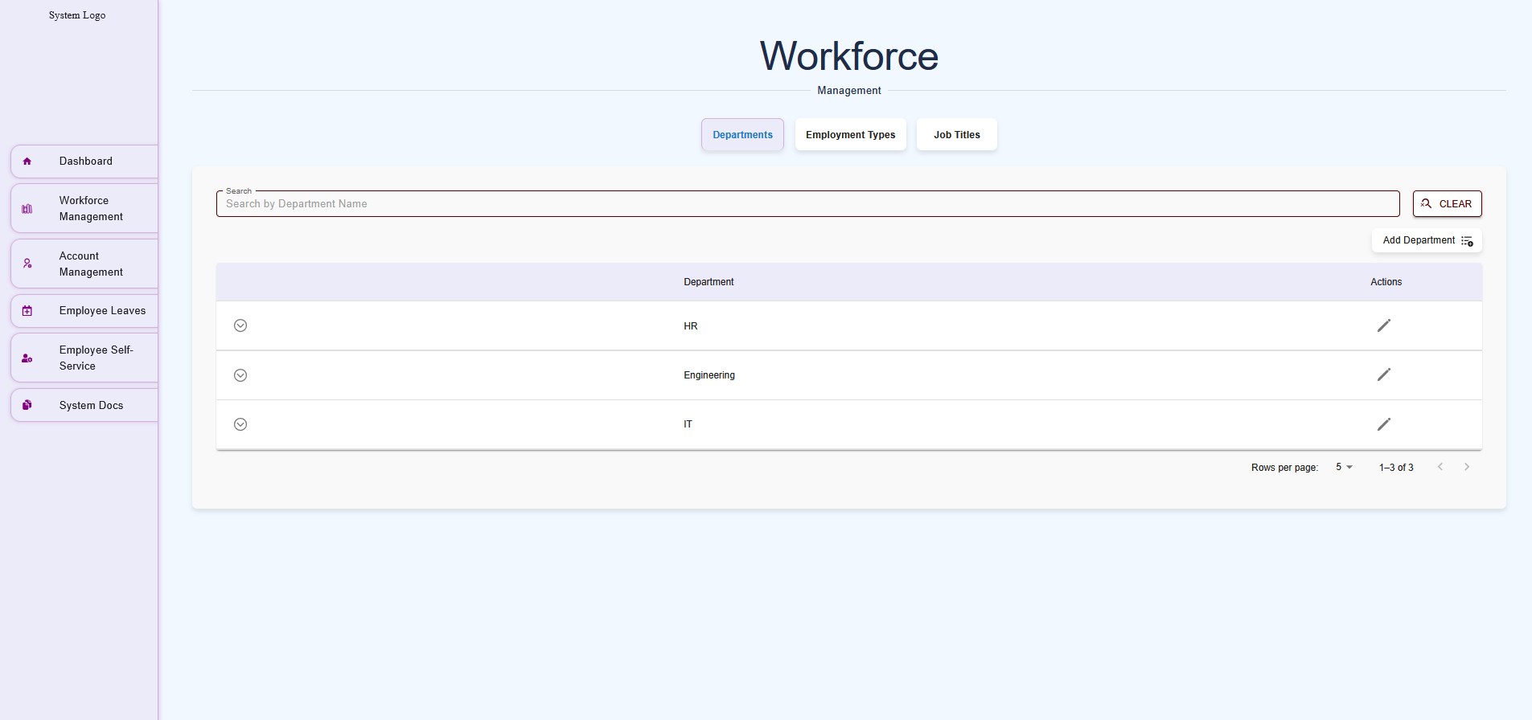

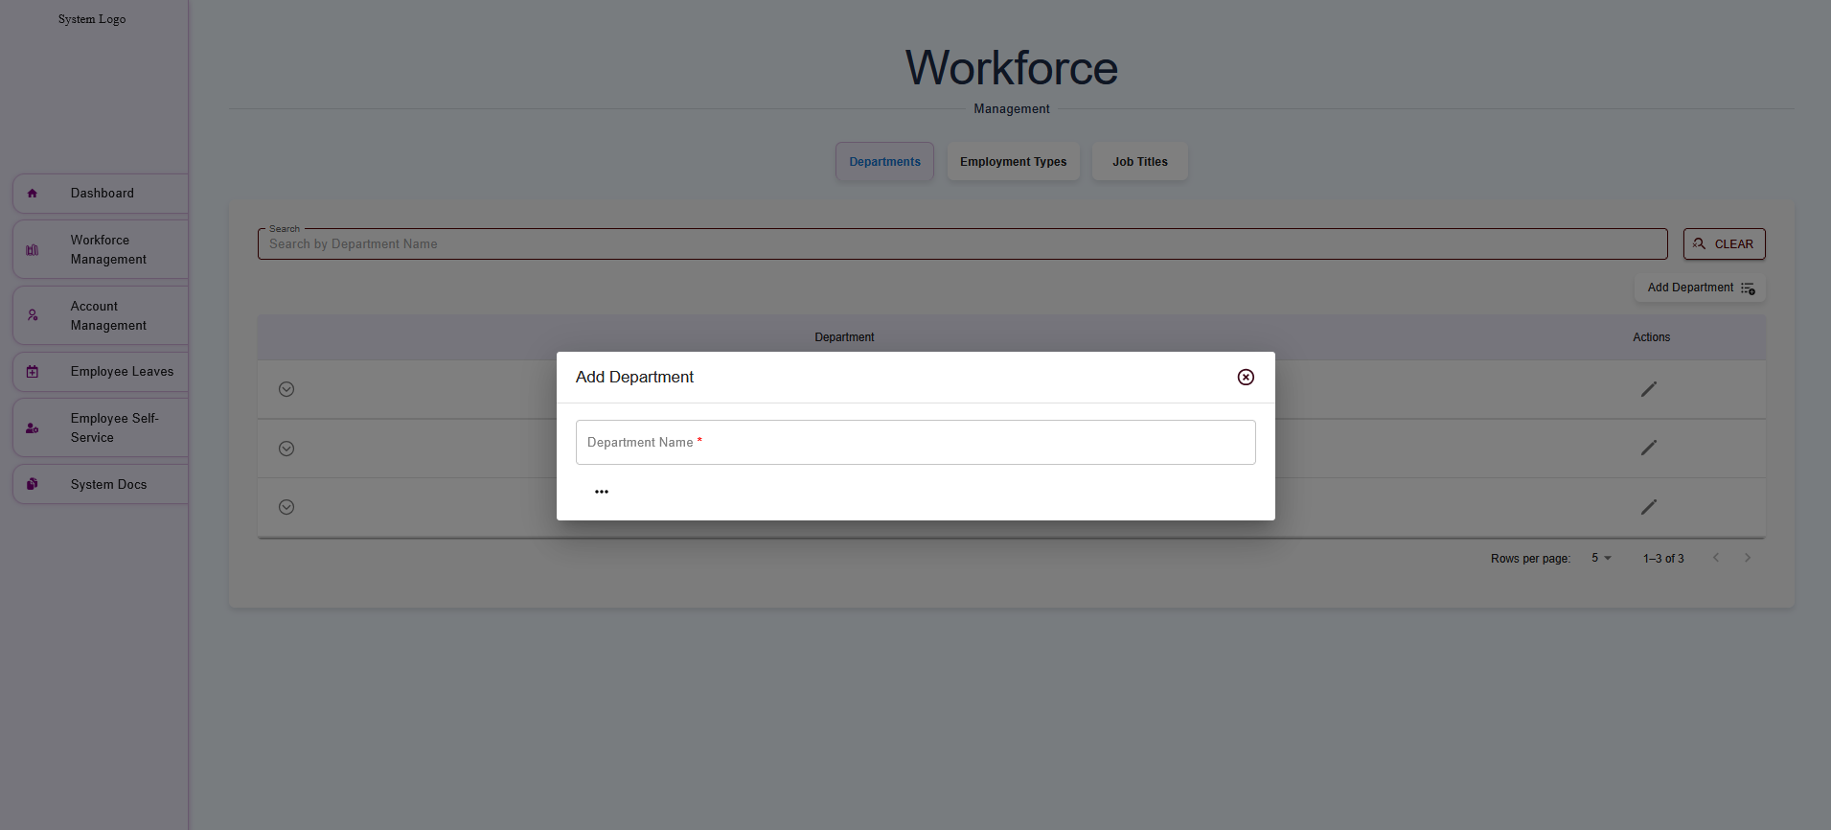

Divisions
Divisions are sub-units within a department, allowing for more granular organization of employees based on specific functions, projects, or teams.
- Purpose: To further segment employees within a department for precise management and reporting (e.g., a Marketing Department may have divisions like Digital Marketing, Content Creation, and Public Relations).
- Examples:
  - Under Finance: Accounts Payable, Accounts Receivable, Tax Compliance.
  - Under IT: Software Development, Network Security, Technical Support.
- Key Features:
  - Assign employees to divisions for detailed reporting.
  - Track division-specific payroll expenses.
  - Map divisions to specific projects or operational goals.

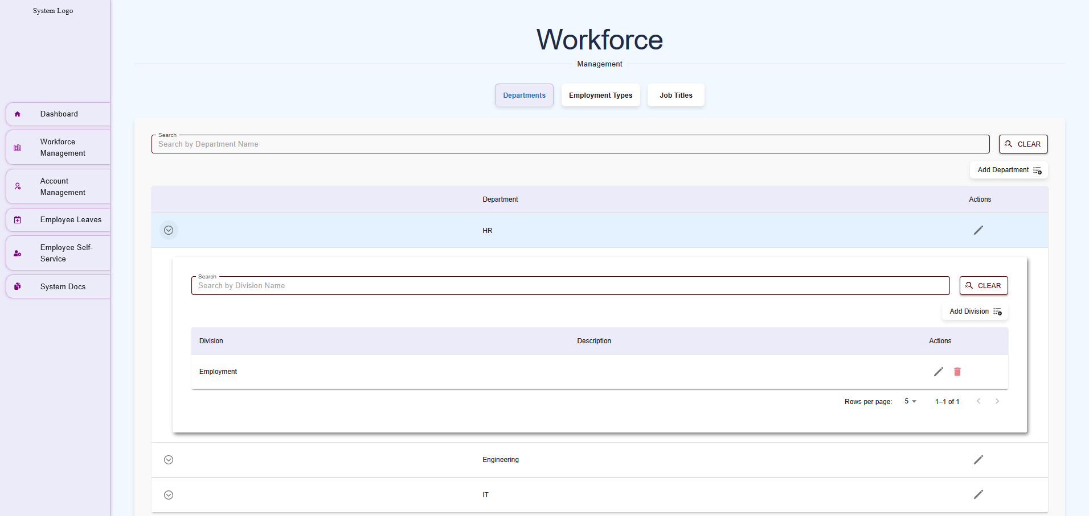

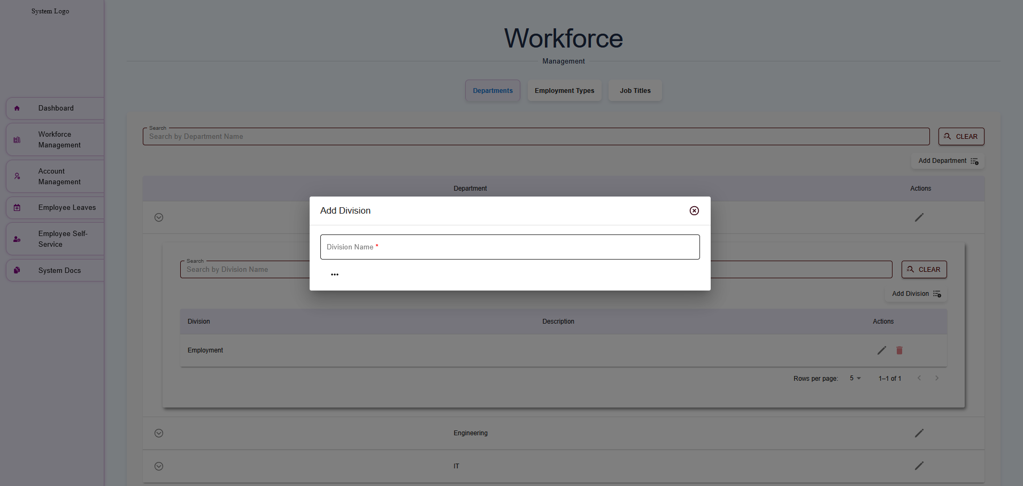

Employment Types
Employment Types define the nature of an employee’s engagement with the organization, such as their work hours, contract status, and eligibility for benefits. This classification directly impacts payroll processing, tax calculations, and compliance with labor laws.

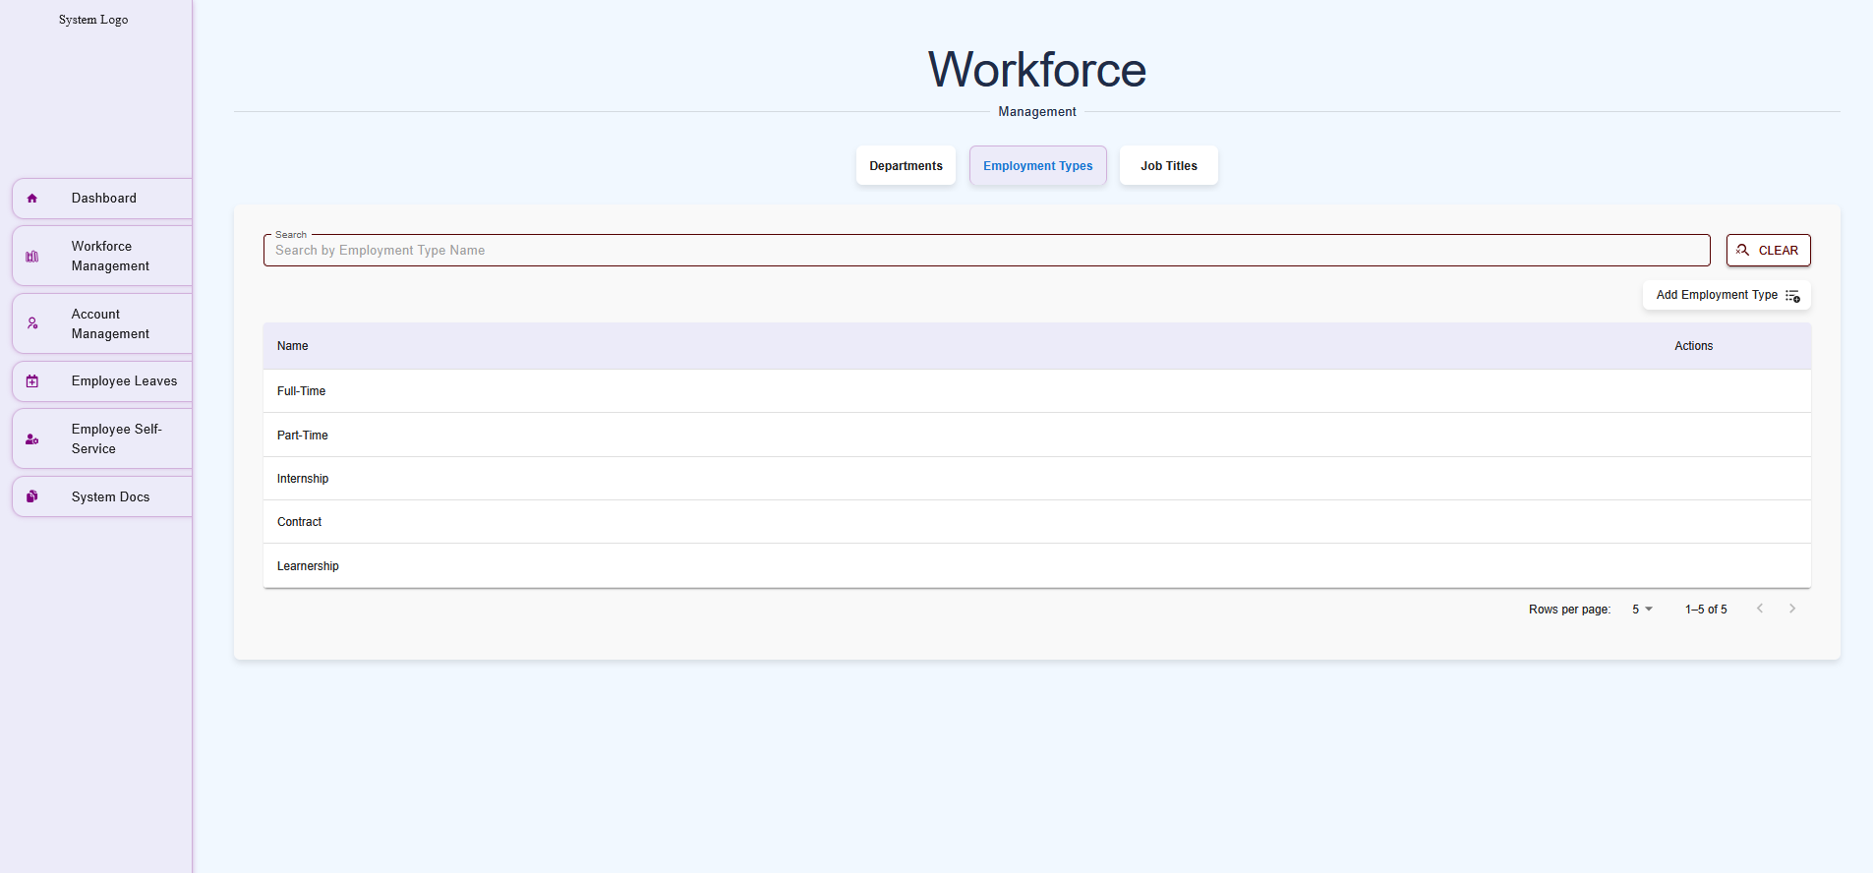

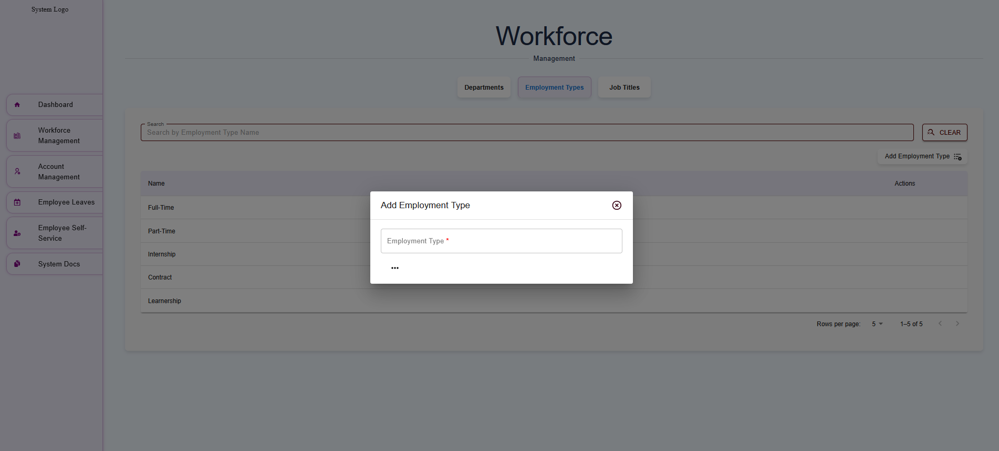

Job Titles
Job Titles represent the specific roles employees hold within the organization. Each title is linked to a department (and optionally a division) and may include details like pay grade, responsibilities, or reporting structure. Job Titles ensure consistency in role definitions and support payroll, performance management, and career progression.

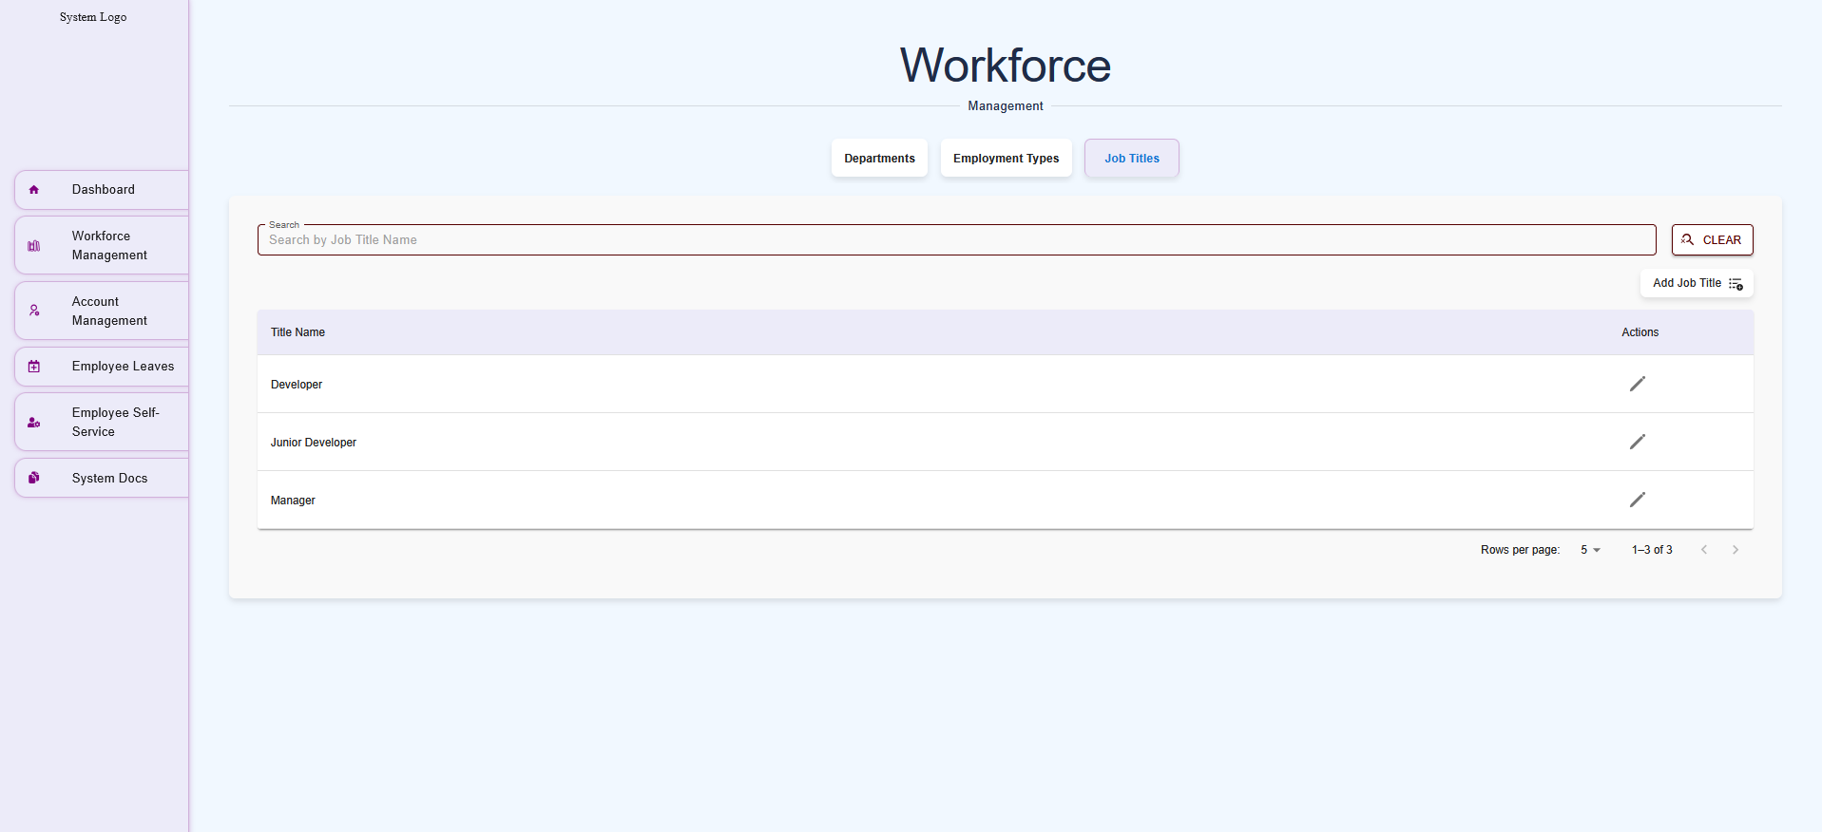
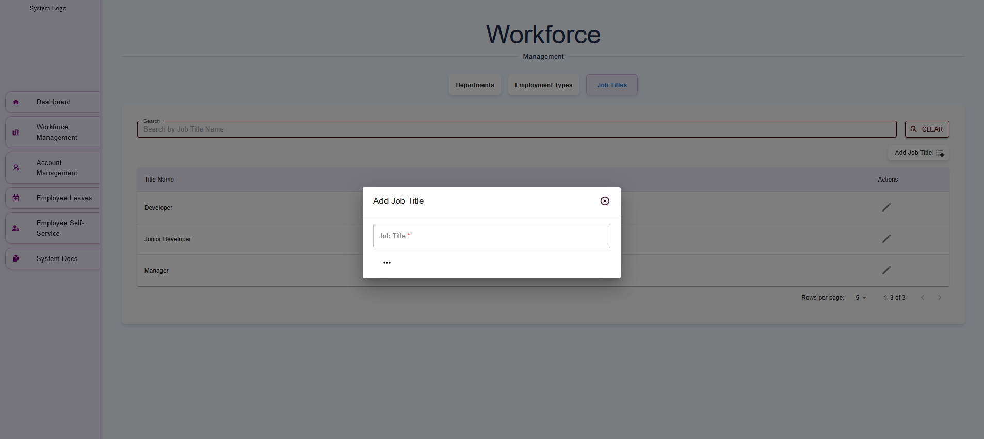

Account Management

Users
The Account Management module of the payroll system allows administrators to create, view, edit, and manage user accounts for employees, HR staff, payroll administrators, and other system users. This module ensures that all users have appropriate access to the payroll system based on their roles, such as viewing pay stubs, managing payroll data, or configuring organizational settings. It integrates with the Workforce Management module to link user accounts to organizational data like Departments, Employment Types (e.g., Full-Time, Part-Time), and Job Titles (e.g., Developer, Technician).
The Account Management module is designed to:
- Create user accounts for employees and system administrators.
- Assign roles and permissions to control access to payroll system features.
- View and manage user details, including their organizational assignments and account status.
- Ensure compliance with security policies by managing user authentication and access levels.
- User Creation: Add new users with personalized account details and role-based access.
- User Viewing and Editing: Review and update user profiles, including contact information, roles, and organizational data.
- Role-Based Access Control (RBAC): Assign roles (e.g., Employee, HR Admin, Payroll Admin) to restrict or grant access to specific modules.
- Account Status Management: Activate, deactivate, or suspend user accounts as needed.
- Audit Trail: Track changes to user accounts for security and compliance purposes.
- Integration: Link user accounts to Workforce Management data (e.g., Department, Employment Type, Job Title) for seamless payroll processing.

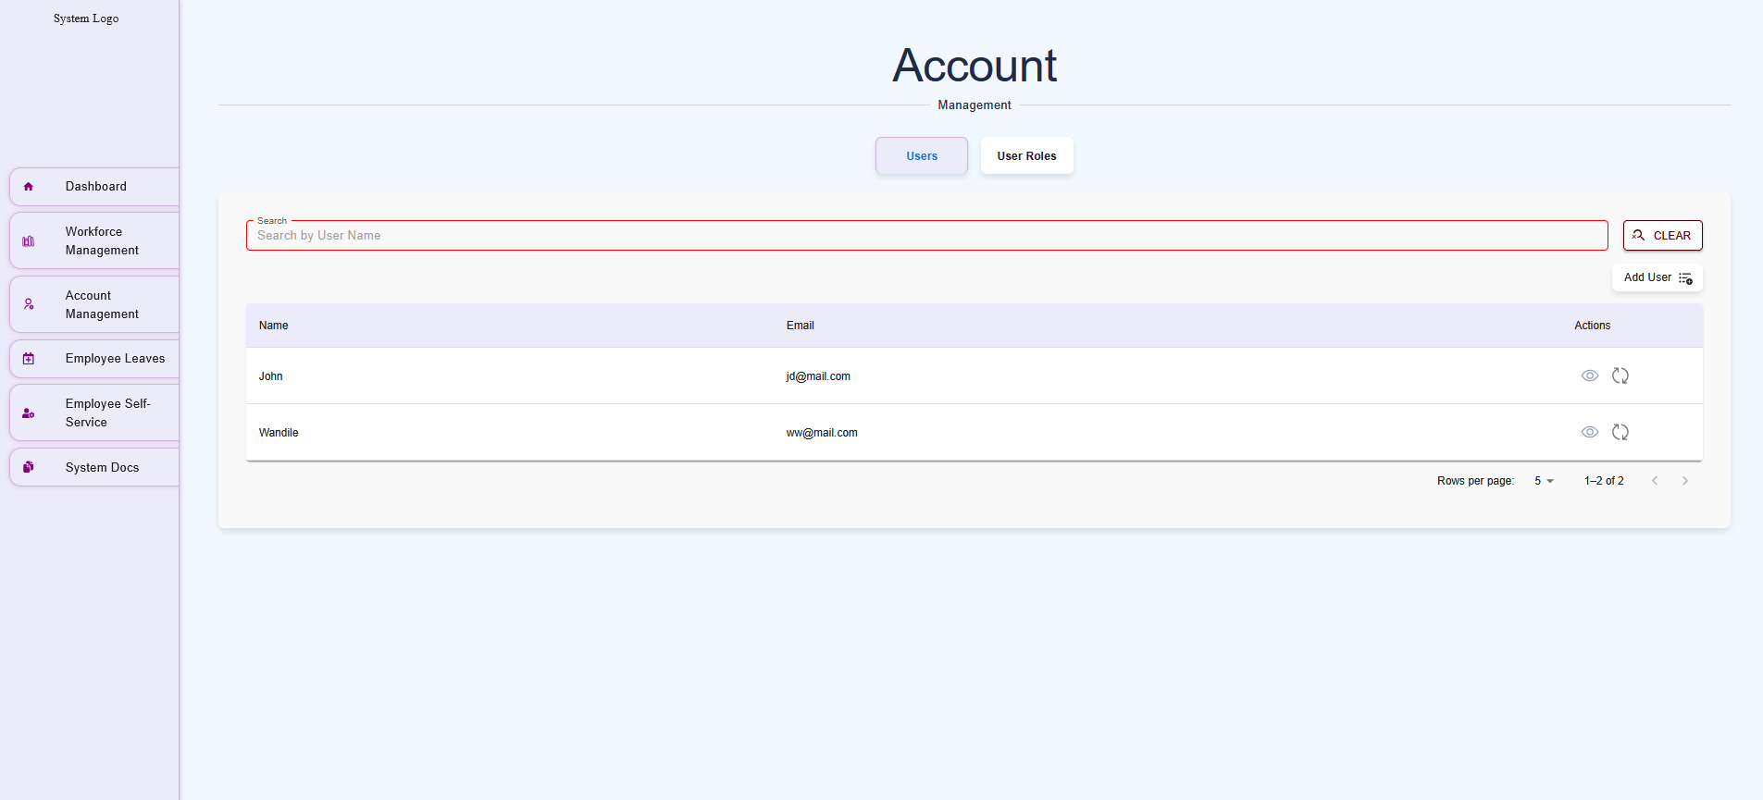
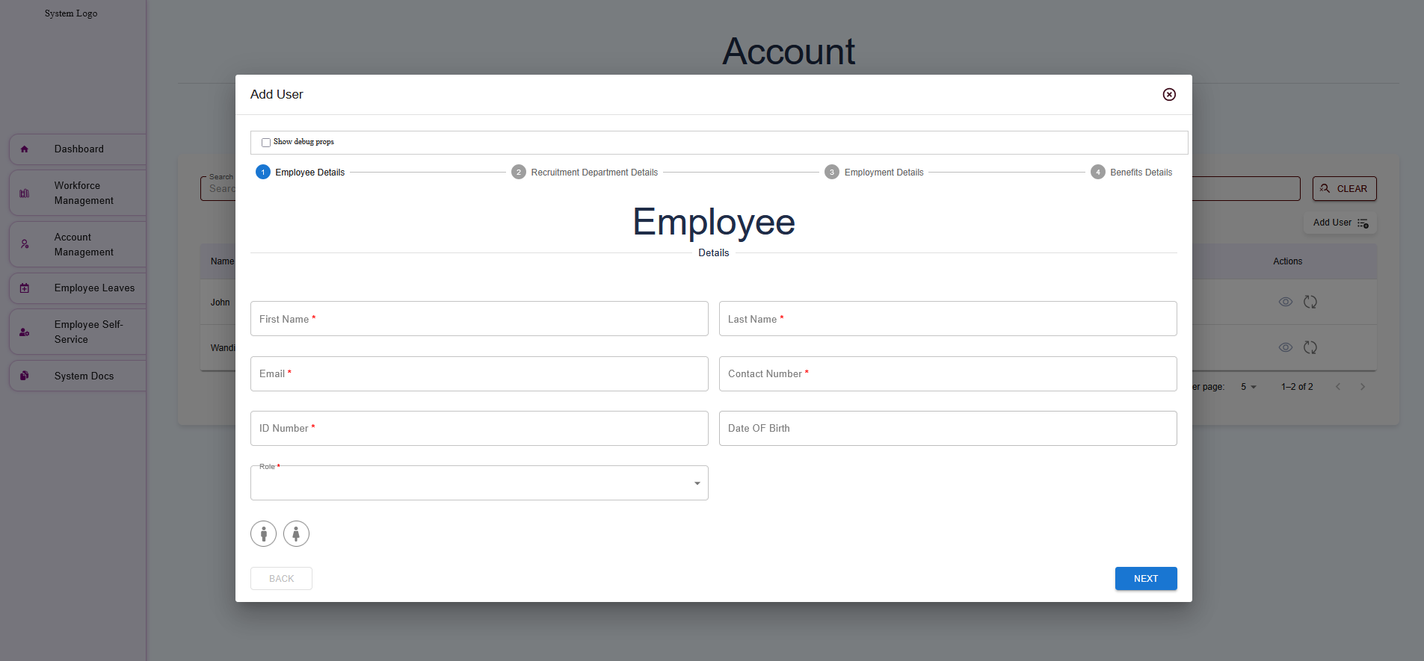
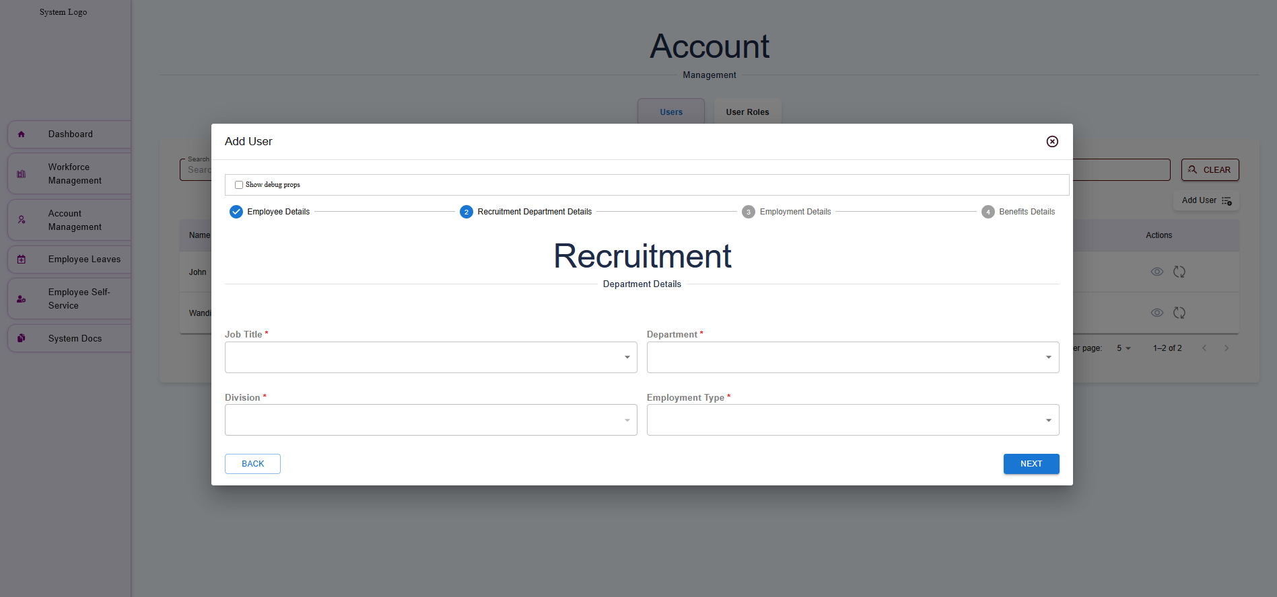
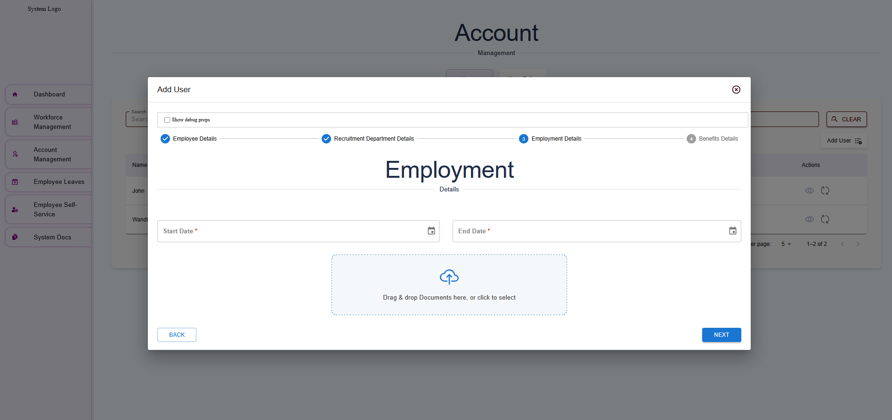
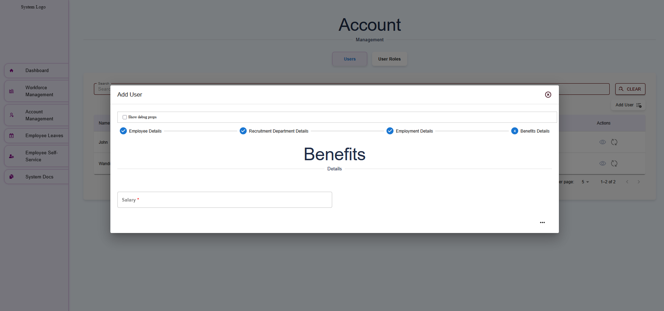

User Roles
The User Roles section within the Account Management module of the payroll system allows administrators to define and assign roles to users, controlling their access to system features and data. Roles are critical for ensuring that users, such as employees, HR staff, or system administrators, have appropriate permissions based on their responsibilities. This section details the Admin and Developer roles, their permissions, and how to manage them, ensuring alignment with organizational data from the Workforce Management module (e.g., Employment Types: Full-Time, Part-Time; Job Titles: Developer, Technician).
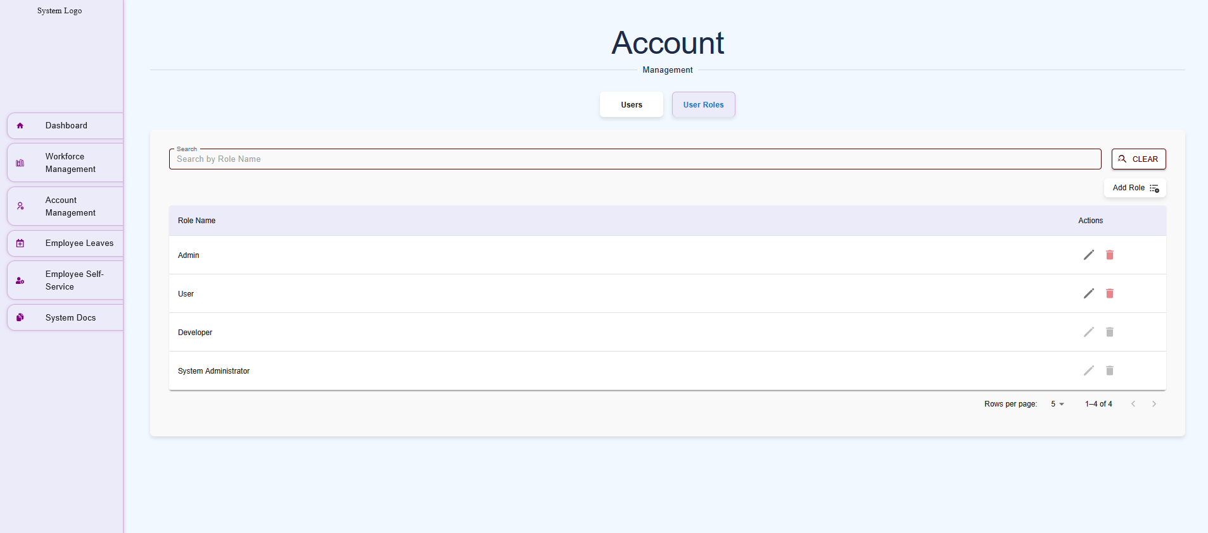
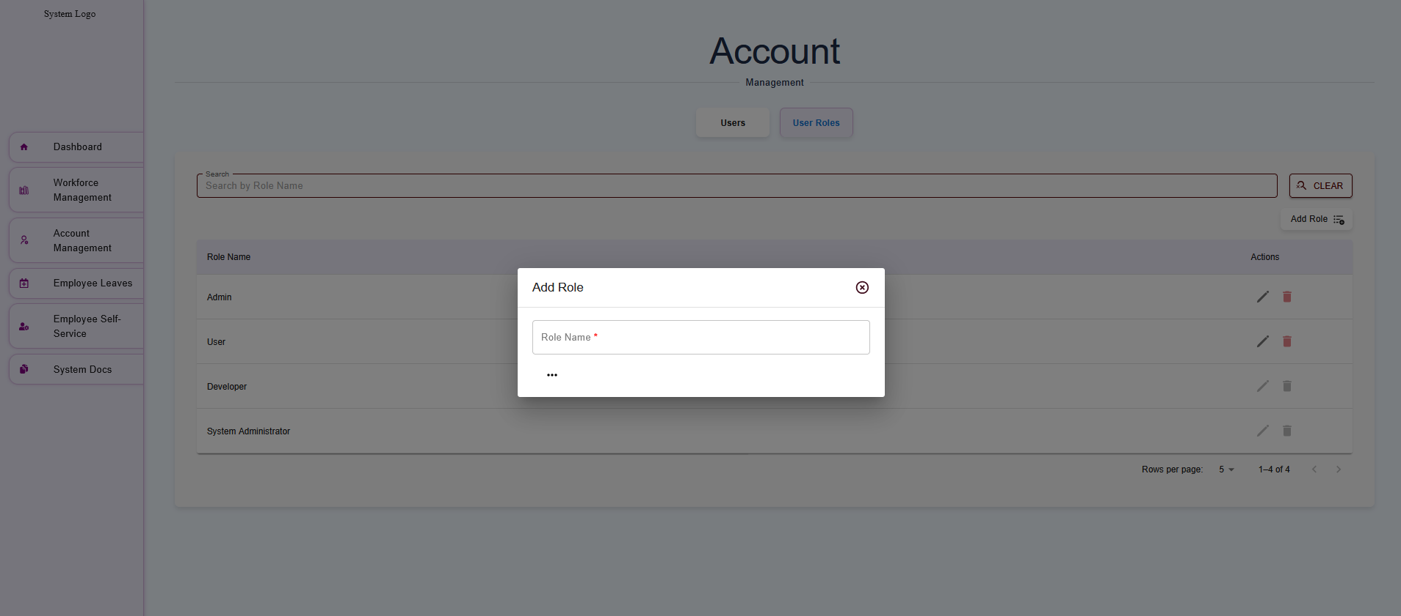

Employee Leaves
The Employee Leaves section allows employees and admins to create and manage leave requests within the payroll system.
Creating a Leave
- Go to Employee Leaves > New requests.
- Select the leave type (e.g., Vacation, Sick).
- In the calendar:
  - Single Day: Double-click the desired day.
  - Multiple Days: Click the start day, then drag to the last day of the leave.
- Enter details (e.g., reason, comments).
- Click Submit to send the request for approval.
Best Practices
- Ensure leave dates align with company policies.
- Admins should review requests promptly in Employee Leaves > Pending Requests.

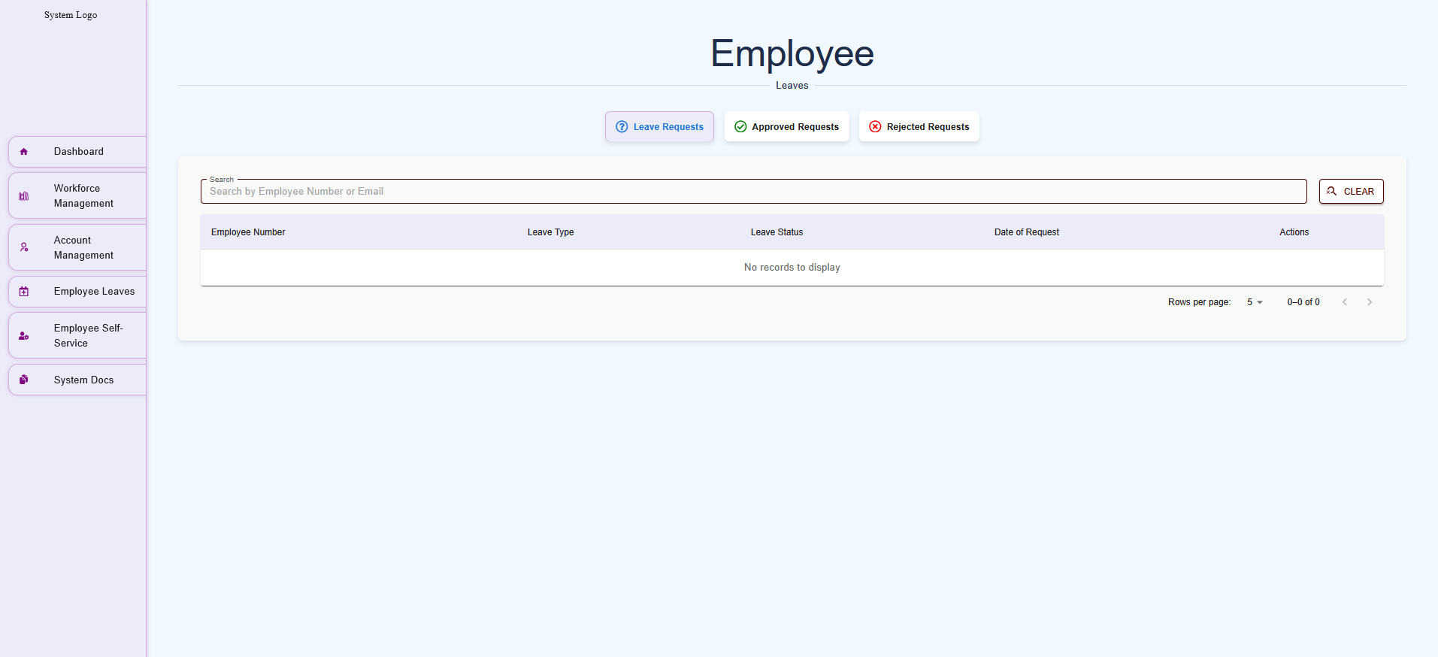

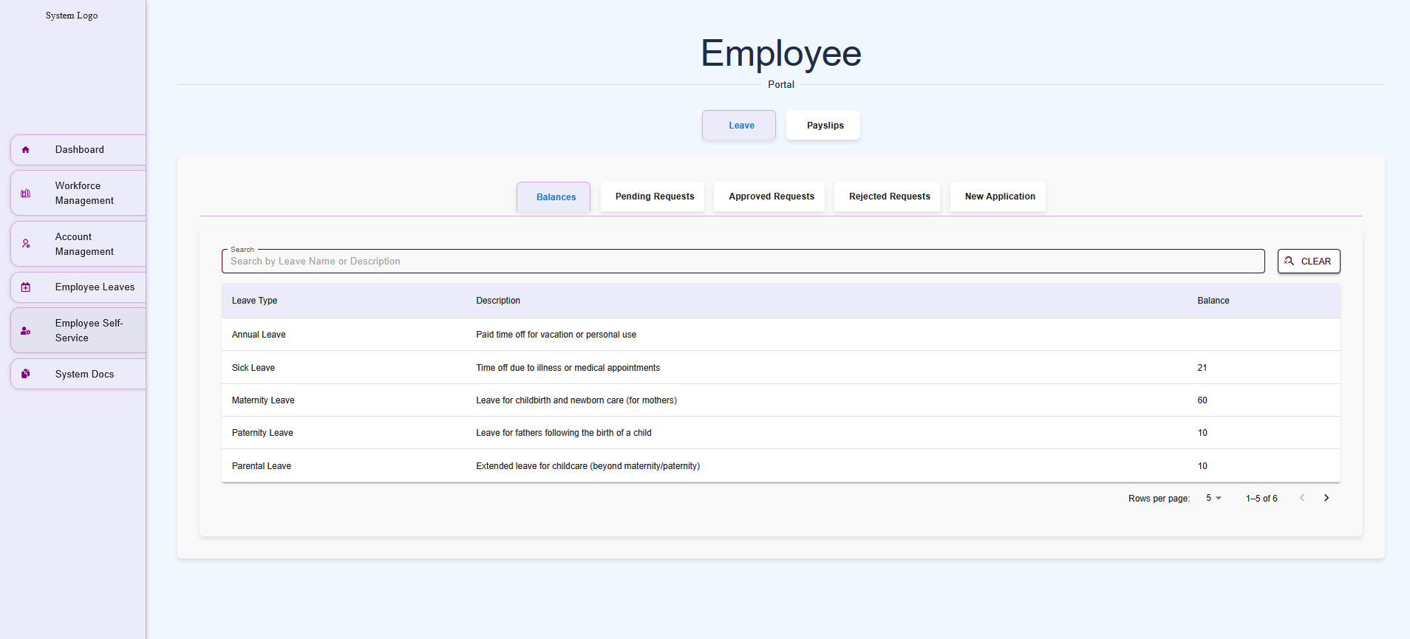

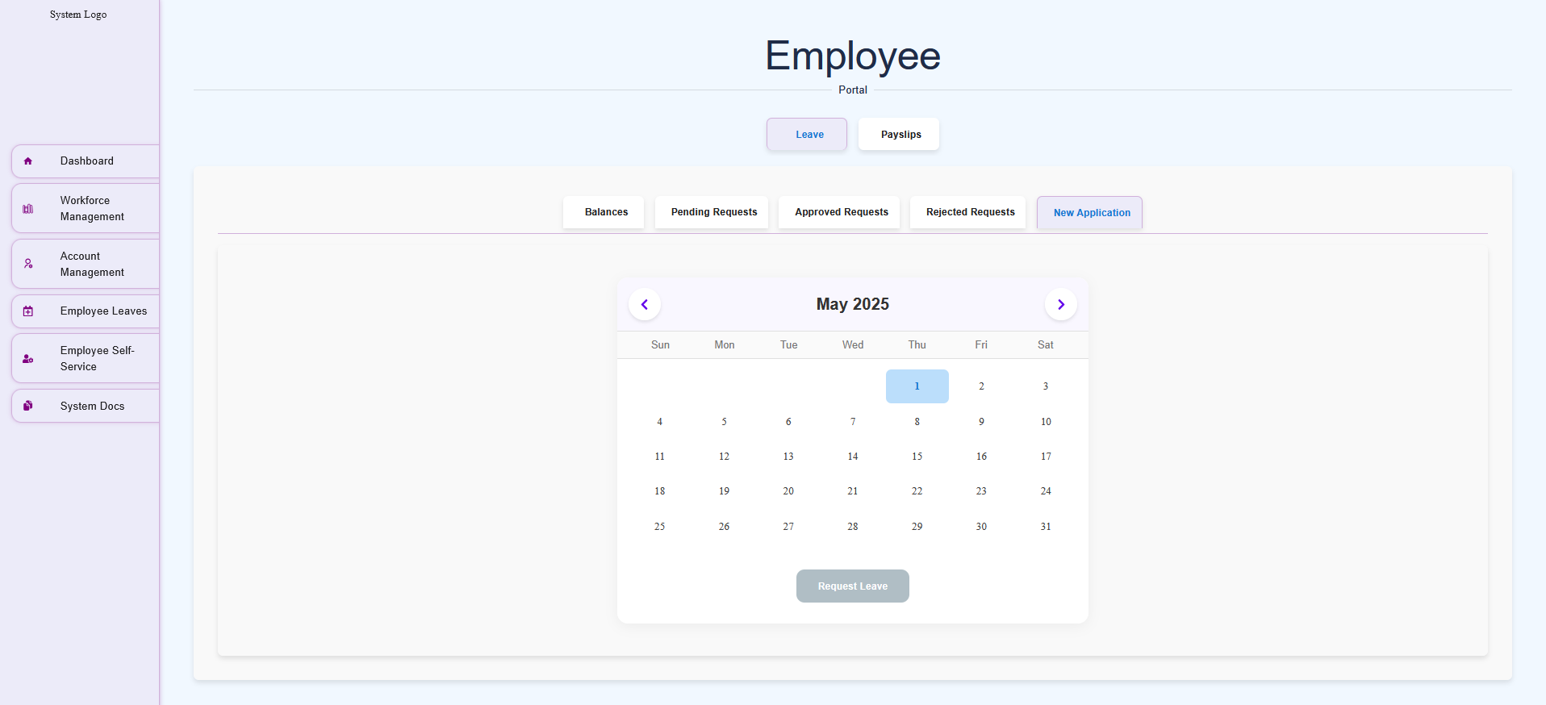

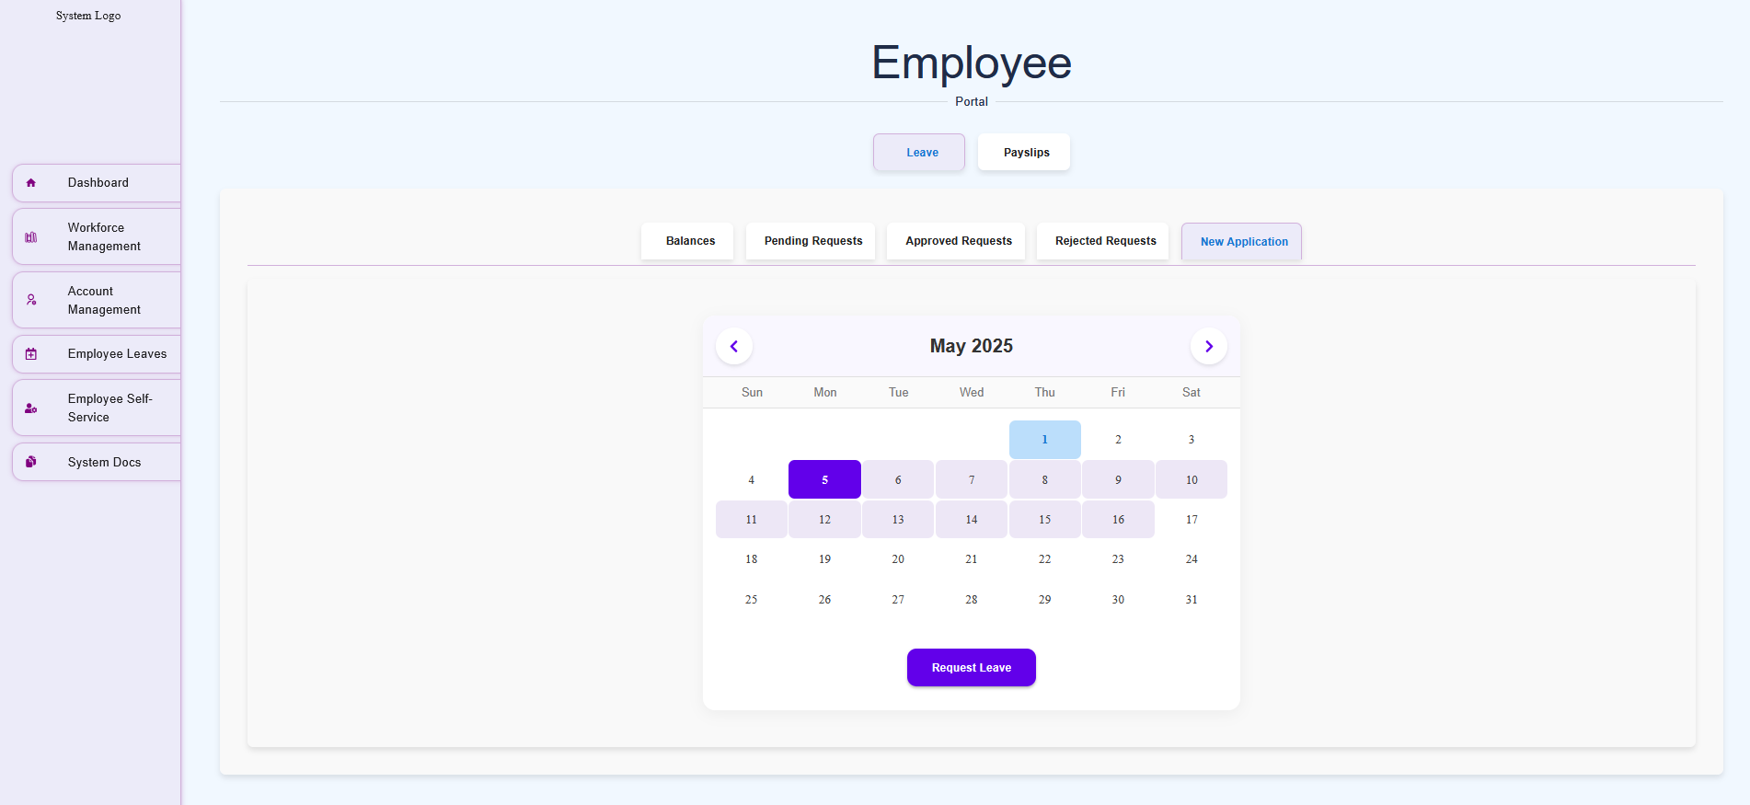
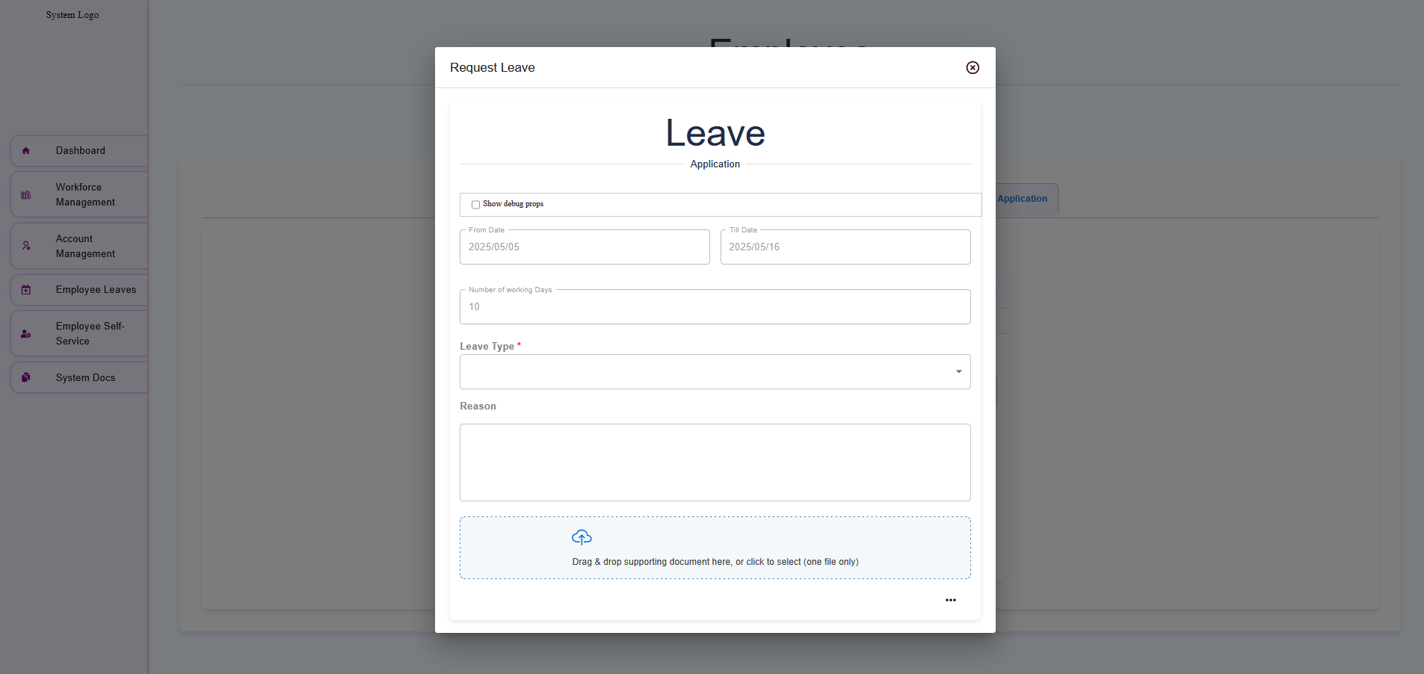

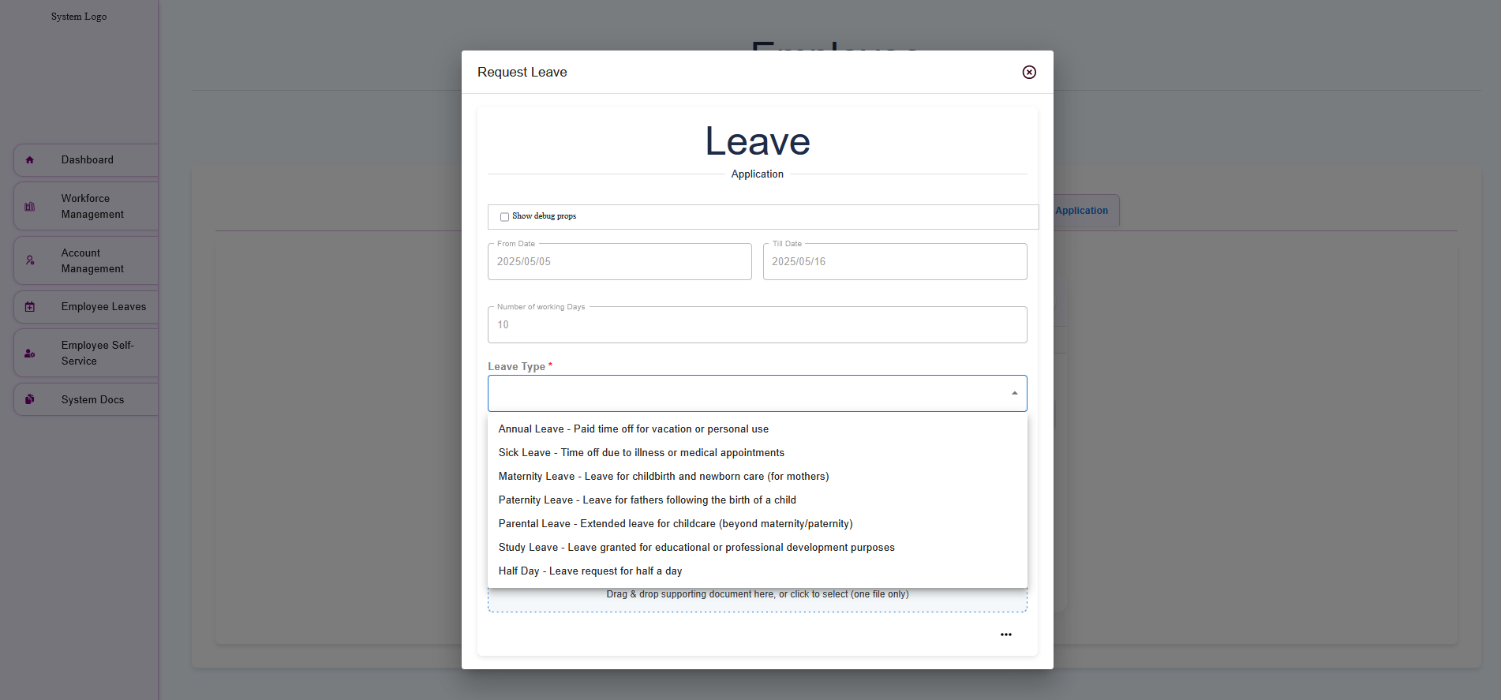

Payslip Generator
For your payslip just filter based on the year and download the desired payslip for that specific month

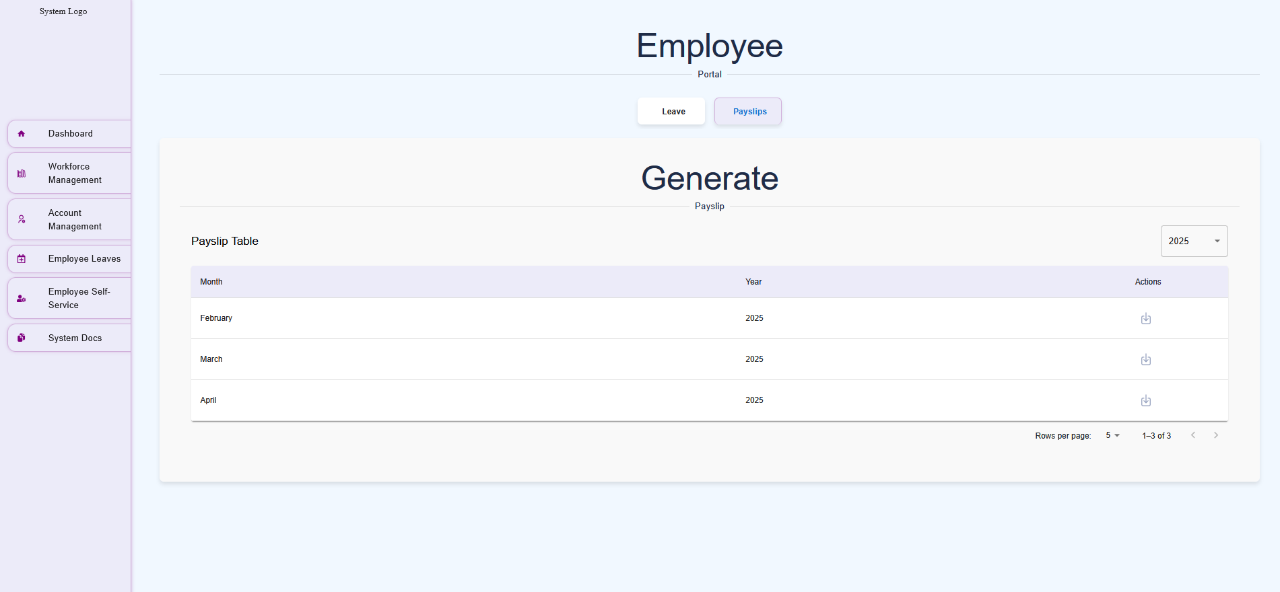

System Documents

Overview
The System Documents module allows Admin users to store, manage, and make system-related documents (e.g., user manuals, guides, policies) available for download by authorized users. This module ensures easy access to critical documentation within the payroll system.

